Exercise 5: Task Management System

Linked Lists

Singly Linked List:
- A data structure where each node contains data and a reference (or pointer) to the next node.
- Traversal is one-directional (from head to tail).

Doubly Linked List:
- Each node contains data, a next pointer, and a previous pointer.
- Allows traversal in both directions (forward and backward).
- Requires more memory than singly linked lists.
Output
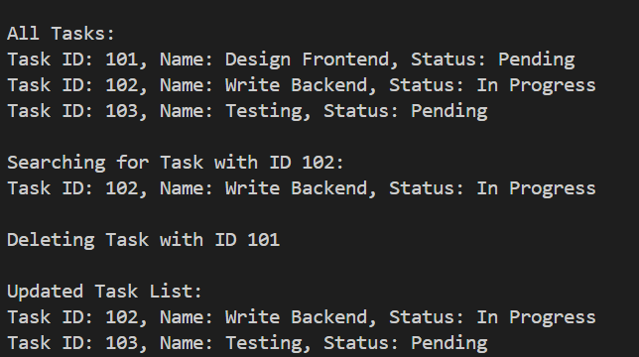

Time Complexity
- Add Task – O(n):
To add a task, we must go through the list to find the end.
- Search Task – O(n):
We check each task one by one until we find a match.
- Traverse Tasks – O(n):
We go through all tasks from start to end.
- Delete Task – O(n):
We need to locate the task before removing it, which takes time.

Why Linked Lists are better than Arrays:
- Dynamic Size:
Linked lists can grow or shrink as needed, while arrays cannot change size after creation.
- Insertion/Deletion:
Linked lists allow easier and faster insertion or deletion when the position is known, unlike arrays that may need shifting.
- Memory Usage:
Linked lists use memory only when needed; arrays reserve a fixed amount in advance.

